A198-Afr-Egy-Ushabti-Saite Period, 26th Dynasty, 570-525 BCE

**Case No.: 2**

**Formal Label:** Ushabti-Saite Period, 26th Dynasty, 570-525 BCE

**Display Description:** Mummiform, plain tripartite wig, arms crossed right over left on the chest; the right hand is holding a pick and a seed basket that is flung over the left shoulder, and the left I holding a hoe. There is a shallow dorsal pillar which merges with the wig, and the entire Ushabti is placed on a trapezoidal base. A “T” shaped inscription names the owner.

**Accession Number: A198**

**LC Classification:** DT62

**Date or Time Horizon:** Saite Period, 26th Dynasty, 570–525 BCE, Reign of Amasis

**Geographical Area: Sais, Egypt**

**Map, GPS Coordinates:** 30.96650 30.76751, 30º57'59.41" N 30º46'3.02" E

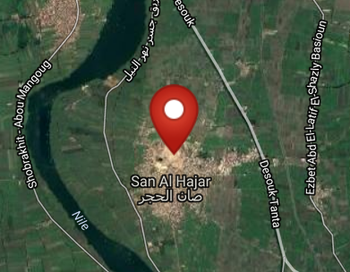 

Fig. Left. Sais on the Nile after http://latitude.to/lat/30.96606/lng/30.76785. Fig. Sais reconstructed according to Jean-Claude Golvin, http://jeanclaudegolvin.com/sais-2/.

**Cultural Affiliation:** Sais Period, Egypt

**Medium:** faience, blue-green glaze

**Dimensions: H 9 cm; 3 9/16 in  
Weight: 21 gm; 5/8 oz**

**Provenance: unknown**

**Condition:** original

**Discussion:** This green glaze faience Ushabti is similar to one in the San Francisco Museum of Art. acc. no. 1925.81

**References:**

Aubert, J.-F. et L. Aubert. 1974. *Statuettes Egyptiennes: Chaouabtis, Ouchebtis.* Paris, 1974.

Janes, Glenn. 2002. *Shabtis. A Private View, Ancient Egyptian Funerary Statuettes in European Private Collections.* Paris: Cybèle.

Newberry, Percy E. 1930-1957. *Funerary Statuettes and Model Sarcophagi.*  Le Caire : Impr. de l'Institut français d'archéologie orientale.

Schneider, Hans D. 1977. *Shabtis - An Introduction to the History of Ancient Egyptian Funerary Statuettes. With a Catalogue of the Collection of Shabtis in the National Museum of Leiden*. (3 volumes, Leiden: Rijksmuseum van Oudheden Te Leiden.

Schlögl, Hermann and Andreas Brodbeck. 1990. *Ägyptische Totenfiguren aus öffentlichen und privaten Sammlungen der Schweiz.* Orbis Biblicus et Orientalis, Series Archeologica, 7. Göttingen, Vandenhoeck & Ruprecht; Freiburg Schweiz, Universitätsverlag.